Asian Parliamentary Assembly
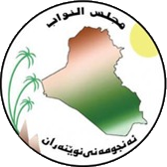 | Standing Committee on Political Affairs  Baghdad, Iraq  11 - 12 January 2025 | 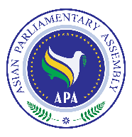
Registration Form

Delegation of:
Name of Parliament
 | Date | Airline & Flight number | Time | Explanation
Arrival
Departure

No. | Delegation Information | Photo
1 | First Name: Last Name:  Passport No:  Passport issue date: Passport expiry date:  Date of birth (d/m/y): Place of birth (City, Country):  ⬜Head of delegation  Phone: Email:
2 | First Name: Last Name:  Passport No:  Passport issue date: Passport expiry date:  Date of birth (d/m/y): Place of birth (City, Country):  ⬜Member of delegation  Phone: Email:
3 | First Name: Last Name:  Passport No:  Passport issue date: Passport expiry date:  Date of birth (d/m/y): Place of birth (City, Country):  ⬜Member of delegation  Phone: Email:
4 | First Name: Last Name:  Passport No:  Passport issue date: Passport expiry date:  Date of birth (d/m/y): Place of birth (City, Country):  ⬜Staff  Phone: Email:

Host Secretariat: | CC to APA Secretariat:
Email: protocol@parliament.iq  Tel : : (+964) 7809295454 | Email : secretariat@asianparliament.org  Fax: (+98-21) 33517408  Phone: (+98-21) 33517406-7

